Scottish Sarcoma MDT  REFERRAL TO SCOTTISH SARCOMA MDT MEETING | 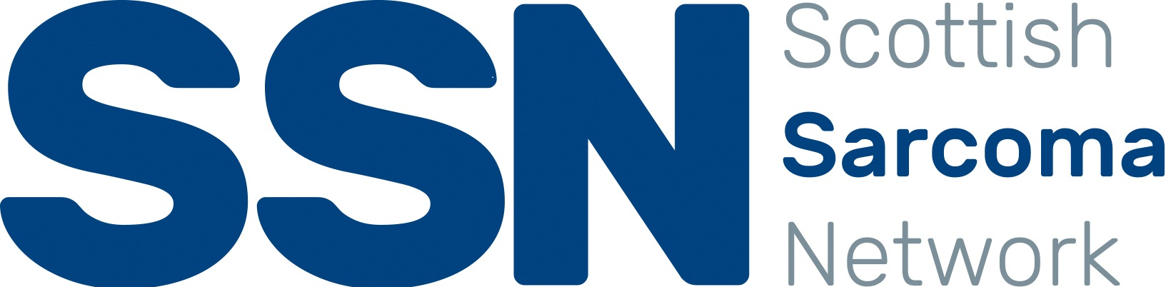
TO BE COMPLETED ELECTRONICALLY

If you wish to participate in the MDT to present your case please contact the Scottish Sarcoma MDT Coordinator for further information: 0141 201 3165 or ggc.scottishsarcomamdt@nhs.scot
Completed referral forms should be forwarded to ggc.scottishsarcomamdt@nhs.scot by Thursday 5:00pm for discussion at the following Monday MDT meeting.
To enable decision-making at the MDT meeting all the requested information should be provided. If the form is inadequately completed the patient may not be discussed.
The patient remains under the care of the consultant referring to MDT meeting unless otherwise stated in MDT outcome.
Completed referral form and associated documentation sent will form part of the patient’s EPR.

MDT REFERRAL / PATIENT / CONSULTANT DETAILS
Date of MDT Referral: |  |  | Click here to enter a date.
Referred to MDT by:
Referrers details: |  |  | Please Note - If you are not the Responsible Consultant please ensure the Responsible Consultant's details are entered below
Reason for Referral to MDT*:
*Please note – GI includes all abdominal and abdominal wall tumours. Other includes breast, head & neck, lung etc.
If a patient has not been discussed at the MDT meeting previously, they should be classed as a new patient.
Patient CHI:
Patient Name:
Responsible Consultant:
Responsible Consultant Contact Tel:
Responsible Consultant email:
Responsible Consultant Address:
CLINICAL DETAILS
Relevant Brief History/Current Symptoms:
ECOG performance status:
0 Fully active, able to carry on all predisease activities without restriction / 1 Restricted in physically strenuous activity but ambulatory and able to carry out light work / 2 Ambulatory and capable of all self care but unable to carry out any work activities / 3 Capable of only limited self-care, confined to bed or char 50% or more of waking hours / 4 Completely disabled, cannot carry on any self-care, totally confined to bed or chair.
For review of imaging at MDT: |  |  |  | If yes, please explain why with a specific clinical question e.g. local recurrence? Isolated metastasis? Suitability for surgical resection?
Imaging details: |  | All imaging MUST have a local report
For review of pathology at MDT: |  |  |  | If yes, please specify date, type of specimen and board:
Pathology details:

Question for MDT:

OTHER INFORMATION
Is patient aware of their potential cancer diagnosis?
Are the patient’s treatment Preferences known (please provide details of the patient’s treatment preferences if known)

Would you agree for patient to be contacted directly through the MDT with an appointment?
Completed forms should be forward to ggc.scottishsarcomamdt@nhs.scot You should receive a confirmation email that case has been received. If you have not received a confirmation email within 5 working days of referral sent, please telephone MDT co-ordinator on 0141 201 3165 to check that referral has been received. After the MDT meeting, the MDT outcome will be uploaded to Clinical Portal and you will be notified of MDT outcome.

